SH: 13A200

SL: 403C2653

1.1. Upload a flowchart that illustrates the ‘flow of data’ between the following components: XBee (left), XBee (right), AD7416 sensor, FTDI breakout, Nucleo F401RE, Windows PC. Make sure to note how each of them interface to each other (3 marks)

1.2. What type of network topology is this ZigBee setup? (1 mark)

Star topology :The star topology consists of a coordinator and several end devices (nodes)

1.3. How does ZigBee compare to some of the other popular wireless IEEE 802 standards like Wi-Fi and Bluetooth? List an advantage and disadvantage of each (1.5 mark)

2.1. What is the 8-bit I2C address of the temperature sensor? (0.5 marks)

1001 1110

2.2. How would you add multiple temperature sensors to this application/setup? i.e., how would the I2C addresses differ? (1 mark)

Change the A0-A2 to be different bits

2.3. What is the purpose of each I2C signal on the waveform you captured in the lab? (0.5 marks)

Yellow: SCL - clock

Green: SDA - data

2.4. Upload your screenshot with the following markups on it:

- Highlight each I2C ‘frame’ of the waveform. Hint: you may want to reference the datasheet of the sensor to help you understand the timing of the waveform

- Label each ‘frame’ with the type of data it holds

- Label each ‘frame’ with its hexadecimal value

- Highlight where we are writing to the sensor (if you wrote) and where we are reading from the sensor (4.5 marks)

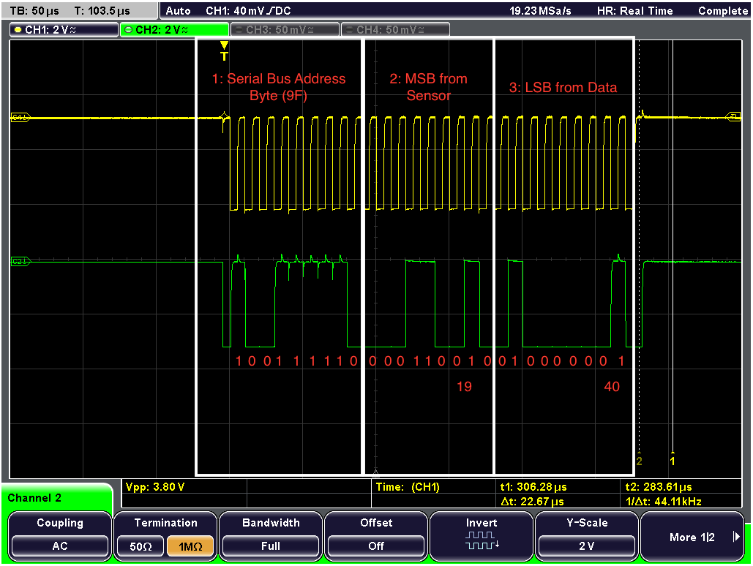

2.5. Why might you need to write to the temperature sensor before reading from it? (1 mark)

If you want to write to slave instead of read from it . the only way that you can change from read to write it to send a stop signal hence you need to write to it.

2.6. How would the code change if you wanted to read a different internal register of the temperature sensor? (0.5 mark)

Change: temperature.read(tempAddress, sda, 2);

Change the bit (Figure 13) refers to

2.7. Explain how your code converts the binary temperature data into a readable, decimal form. Make sure to explain all of the math and binary arrangements you had to do (3 marks)

Shifting the first bit to the left (twice) and shifting the second bit to the right (6 times) and ORs these to values together - then divided the value by 4 (\*0.25)

2.8. What temperature does your screenshot read? (0.5 marks)

25 degrees celsius / room temperature

2.9. Which device is the I2C ‘master’? (0.5 marks)

microcontroller

2.10. Which device is the I2C ‘slave’? (0.5 marks)

Temperature sensor

2.11. How many I2C modules are supported by this microcontroller? (0.5 marks)

Up to 3

2.12. How many UART modules are supported by this microcontroller? (0.5 marks)

Up to 3

2.13. Serial channels have a number of different parameters that must be set in order for two devices to communicate properly (e.g., baud rate, stop bits). In this lab, we let mbed take care of the setup. List the default serial settings in mbed? (1 mark)

Baud rate: 9600

Data length: 8 bits